**Crowdfunding Analysis**

Purpose: We are to analyze data given of 1000 crowdfunding campaigns from a year range of 2010 to 2020. We then draw conclusions on why some succeeded, failed, or canceled. We also discuss some limitations on why this set of data is lacking.

* Given the data provided, what are three conclusions that we can draw about crowdfunding campaigns?
  + 1. The crowdfunding campaign amounts in each country. Looking at the seven countries we see that excluding the US, the other six all have below 50. While the US alone garnished 736. The success rate of each campaign for the country also showed hovering 50% or above. Based on the number of campaigns per country the data should be looked at in two perspectives. The US and everyone else. If you added every outcome together, the six countries hardly come close to US numbers. 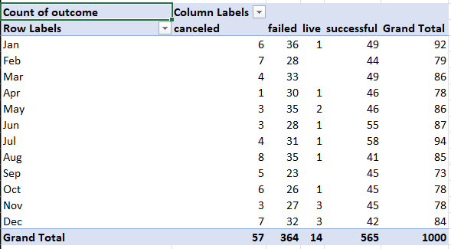
    2. How well each category did. In terms of success, failed and canceled, theater had the most with a total of 187 success, 132 failed, and 23 canceled. The least amount of success was journalism with 4. The least failed was photography with 11, and the least canceled was games with 1.

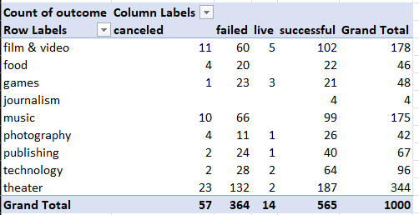

* + 1. The month of July is high for successful campaigns. As compared to major holiday months like November, December, and January. This could be due to the holiday season spending playing a factor into less amount into campaigns due to shopping for gifts.
  + States limitations of the dataset and suggestions for additional tables of graph.
    1. I’d say the sample size is one of the biggest limitations. It is only a 1000 which seemed to be biased towards theater centric campaigns.
    2. Some additional tables or graphs could be made for categories within subcategories. Using music as an example, can separate the genres of music that were more successful.